

CORVETTES OF CANBERRA
CLUB NEWSLETTER

March 2025 92nd EDITION

_________________________________________________________________________________________

REGULAR EVENTS – more details by text message
Club Dinners – First Friday of the month
Club Drives – First Sunday of the month, 9.30am from The Eagle, Russell, for 10am departure

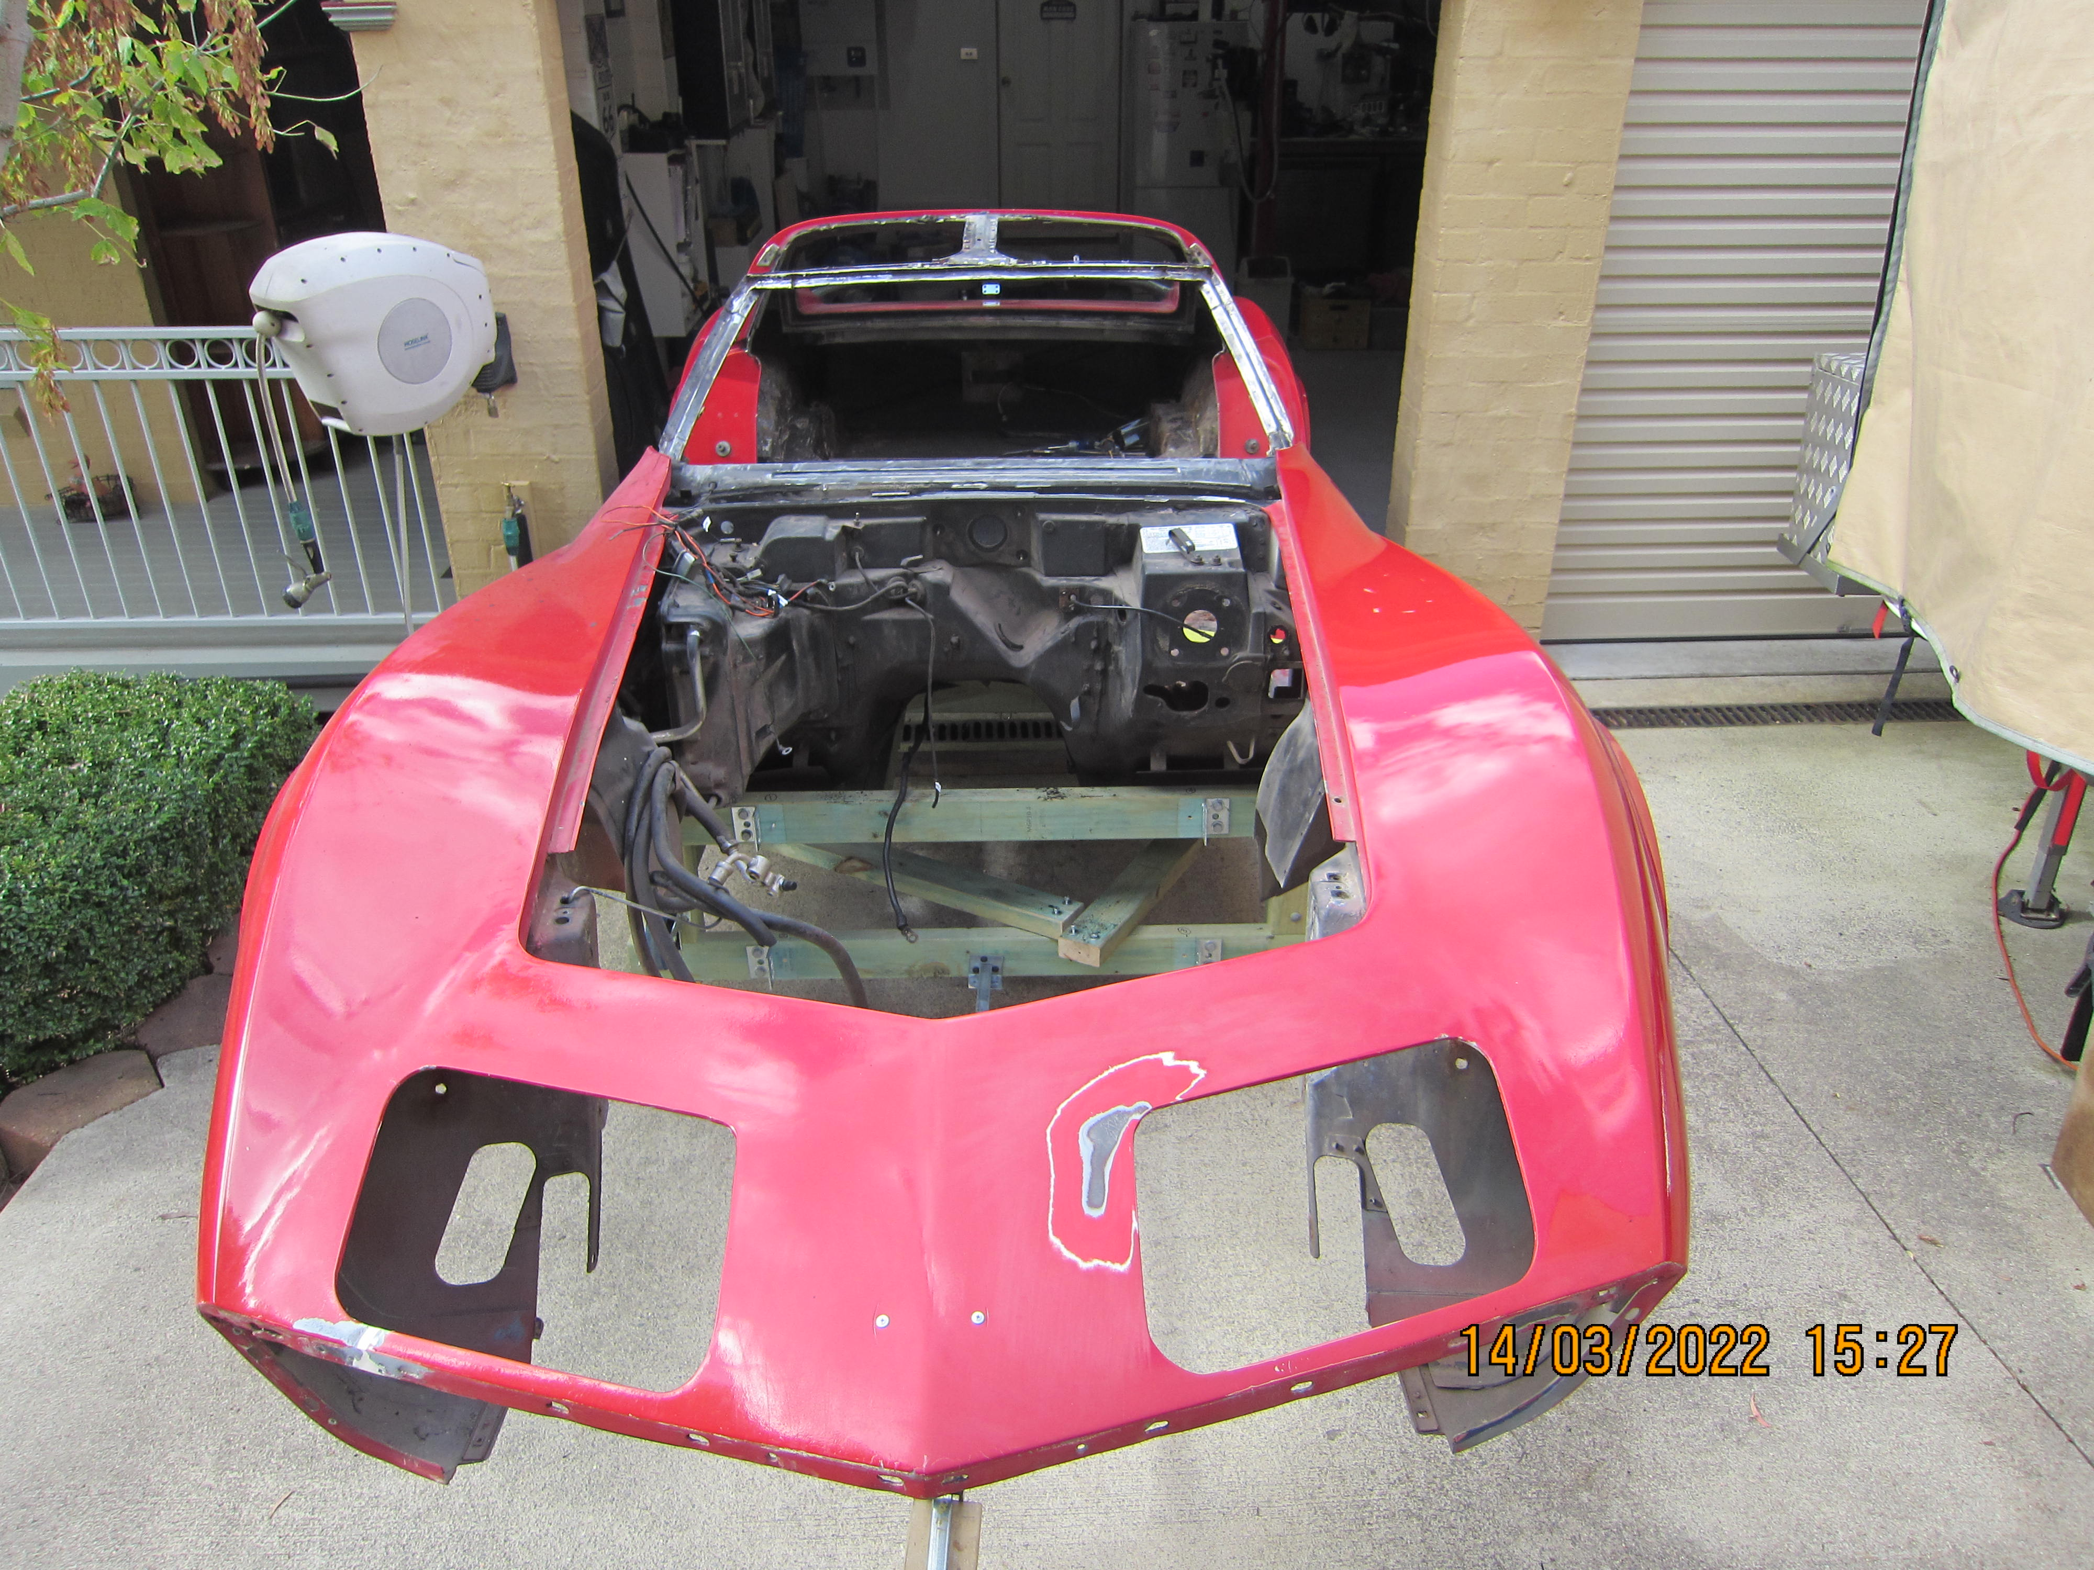

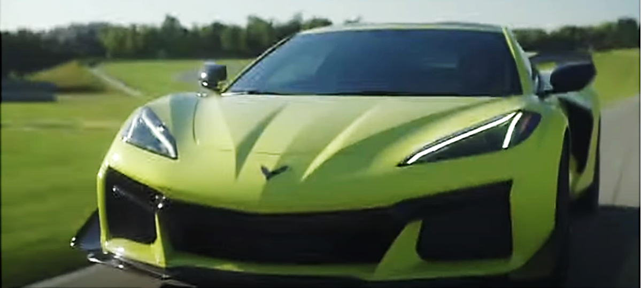

I Need a Stinger on the truck

In this edition:

President’s Report
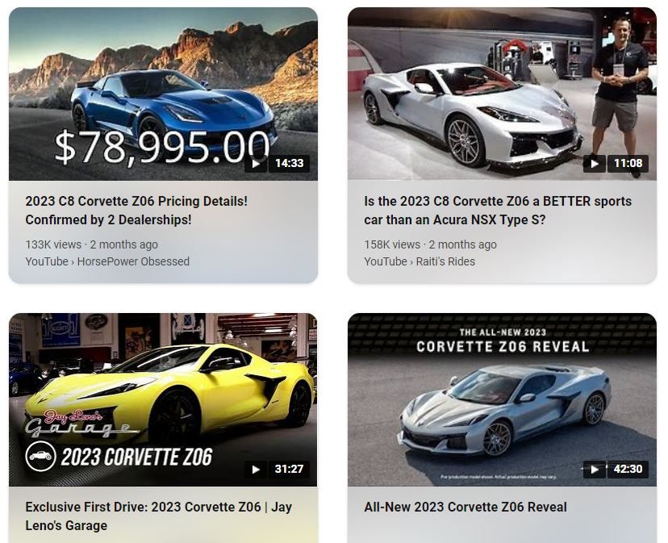

Corvette Nationals Dates for 2025-2030

Important information regarding the QLD 2026 Nationals

Dave Ashworth’s ’72 Roadster is featured

Peter Steve’s parts for sale

A word from our sponsors

C2 Restomod
Underway!

Checkout

Checkout

President
Terry Ruse
0418 430 484

Vice President
Errol Pentland
0447 602 664

Events Coordinator
Peter Bond
0424 122 213

Treasurer
Mark Grey
0401 726 227

Secretary
Peter Bond

Website Manager
Joe Hlubucek

Newsletter
Phil O’Mara
0419 697 066

Registrar
Peter Bond

Public Officer
Terry Smith
0438 668 629

Committee Members
Terry Smith
Michelle Fraser
0412 011 988
Phil O’Mara

Life Members
Peter Steve
Steve Gough
Terry Ruse
Michelle Fraser

President's Report

Hi all,

Our usual members are going to the NSW Nationals in Parkes.

In our next newsletter you will read a more detailed report on next year’s Nationals in Qld. Please read Brad Stumer’s introduction below.

It would be nice to have a few more members going.

Use it as a holiday!

As a club we will continue having club dinners and runs. We will attempt to have an overnight to the coast. It would be great to have your feedback on our newsletter.

Happy ‘Vetting, Terry Ruse

ORDER YOUR CLUB SHIRT NOW!
Lyn McKenzie at Canberra Workwear,
tel 6253 0069
- Add your Vette model on the sleeve!
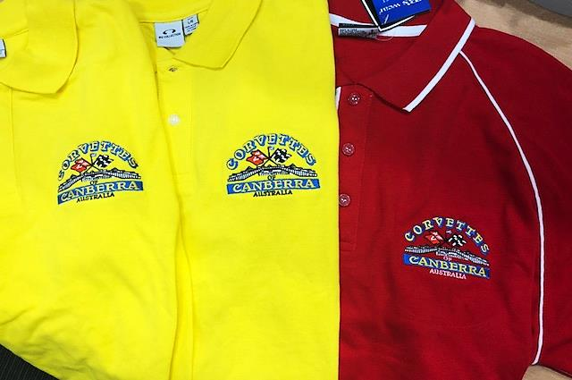

Corvette Nationals Dates for 2025-2030

2025 – Parkes, NSW. 28 to 31 March inclusive

2026–QLD; 2027–SA; 2028–ACT; 2029–WA; 2030 –VIC.

Dear Australian Corvette Clubs,
I hope this email finds you all well.
As some of you may already know, Corvettes Down Under Car Club is facing significant challenges and, unfortunately, has had to step back from organising the Nationals in 2026. They only informed us of this a couple of months ago, which has put considerable pressure on the Queensland Corvette Club (QCC) to take on the responsibility of making the event happen.
Like many clubs, we're facing the challenge of not having enough enthusiastic members, with the older generation gradually moving on. That said, my wife Sandy and I, along with a small committee from our club, have stepped up to ensure we can deliver a fantastic Nationals in 2026. We've attended 20 Nationals so far, with our 21st just around the corner in Parkes in a couple of weeks.
These events are incredibly special, and I would like to take this opportunity to thank all the clubs and members who have helped organise these events, starting with the very first one in Melbourne in 1980 by the Corvette Car Club of Australia.
I’ll be presenting our event at the Gala Dinner in Parkes and will send you our brochure and registration details once I return.
Thank you for your support, and I look forward to seeing you all at the Nationals in 2026!
For and on behalf of the Queensland Corvette Club Inc.
Regards,
Brad Stumer / Chairman 2026 Nationals
Mob: 0414 730 833
- - - - - - - - - - - - - - - - - - - - - - - - - - - - - - - - - - - - - - - - - - - - - - - - - - - - - - - - - - - - - - - - - - - - - - -
Your email address is currently on the Qld. Corvette Club Inc. Nationals database and we believe we at present have your consent to use this as a means of communication with you for our Club events/news. While we hope you find our communications with you useful and informative, we do not wish to send you unwanted emails. If you no longer wish to receive this type of communication please let us know, otherwise we will presume that you are happy to continue to receive our emails.

Queensland Corvette Club Inc.
PO Box 1094 SUNNYBANK HILLS QLD 4109 Website: www.qldcorvetteclub.com.au

The Corvette Nationals is a premier event that brings together passionate enthusiasts of the iconic American sports car, the Corvette. This year marks the 36th edition of the Nationals, and it promises to be bigger and better than ever. ‘Get Your Kicks in 26’ is proudly hosted by the Queensland Corvette Club Inc. and with our valued Sponsors we will be in a stunning location on the Sunshine Coast, the 4-day event is scheduled to take place 2 weeks before Easter.

Dave Ashworth’s ’72 Roadster

Here is a short summary of the project and how I ended up with where it is today.

Back in 2005, arrived the chance to buy my mid-life crisis early. So, what looked to be a fairly clean corvette Stingray, a car that I had been a fan of for as long as I can remember, I always loved the lines and the shape.

After clearing the purchase with my very understanding wife Wendy, the new acquisition came home. As a mechanic by trade who had escaped the industry, I should have looked closer and made a more informed choice to purchase… not jumped in boots and all.

As you do when you get a new toy, you give it a birthday oil change and a tune up. So, as the oil came out so did pieces of plastic. Original nylon timing gear was in the process of failing, so out came the engine for a freshen up.

While the engine was out it seemed like a good idea to do the suspension up, bushes and ball joints. Everything in the front end was toast; the rear end was even worse. Rebushing the rear end, the trailing arm bolts were frozen in, and in backwards (I still can't work out how it was done, maybe from factory?) so I decided to put the shell off to make the job easier for a full frame and running gear redo.

This is where where the journey down the rabbit hole began for full resto.

The shell had had several poor repairs, and the white paint was showing its age. While repairing the shell, I found the original colour Eckhart green, which looked a pretty decent colour, so I decided to bring it back to original.

Life then got in the way. We had three wonderful sons, so the car went to the back burner. It sat taking up space in the shed until covid, when I had time to get stuck back into putting it back together. Everything was done in my garage except the final paint which a friend did for me at Fuller Brothers over one weekend.

As they say the final 5% takes the most time assembly, trimming etc.

I registered it in late 2023 and did about 2500km when it developed an engine miss and a slight knock. Out came the engine where I found a lobe missing off the cam. I suspect that the engine sitting for so long was the reason for the cam failure due to all the assembly lube drying while sitting. In hindsight I should have pulled it down.

I replaced the cam, installed new alloy heads and fitted a Holley Sniper 2 fuel injection setup.
I still have a few small things to sort out but I'm fairly happy with the end result.

Cheers
Dave

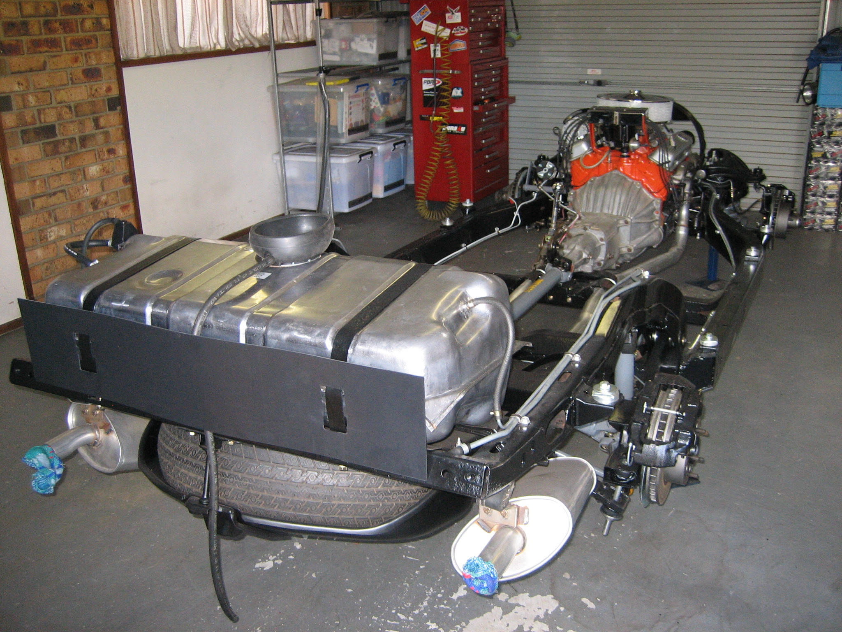
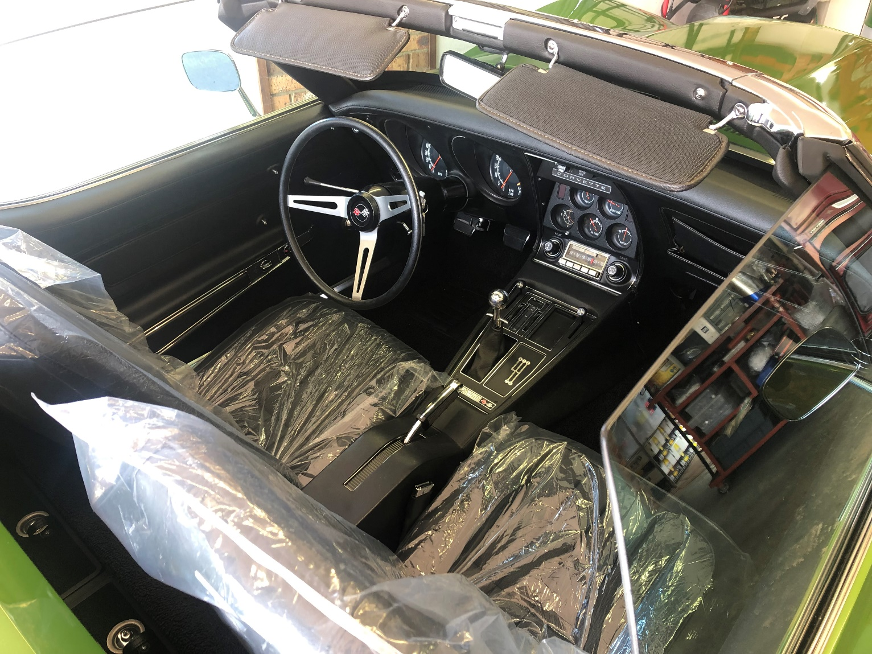

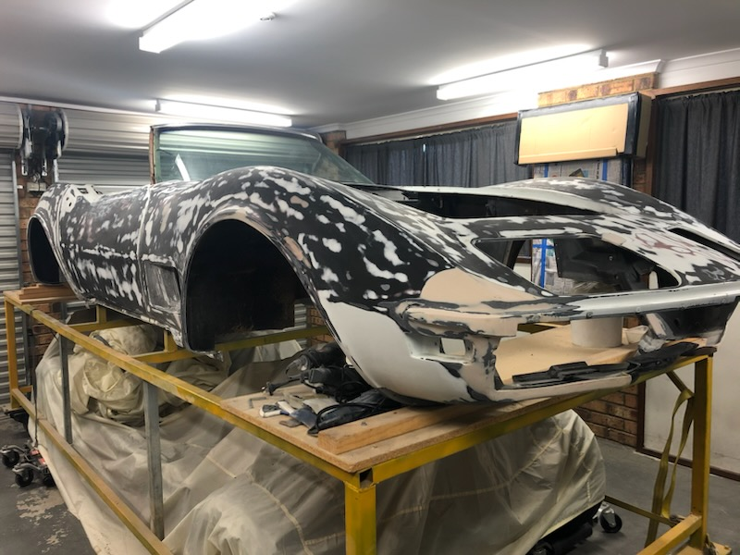
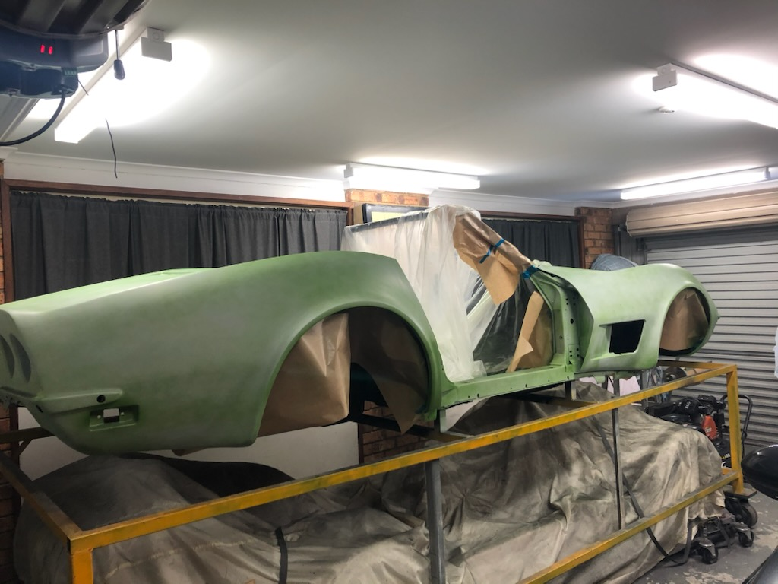
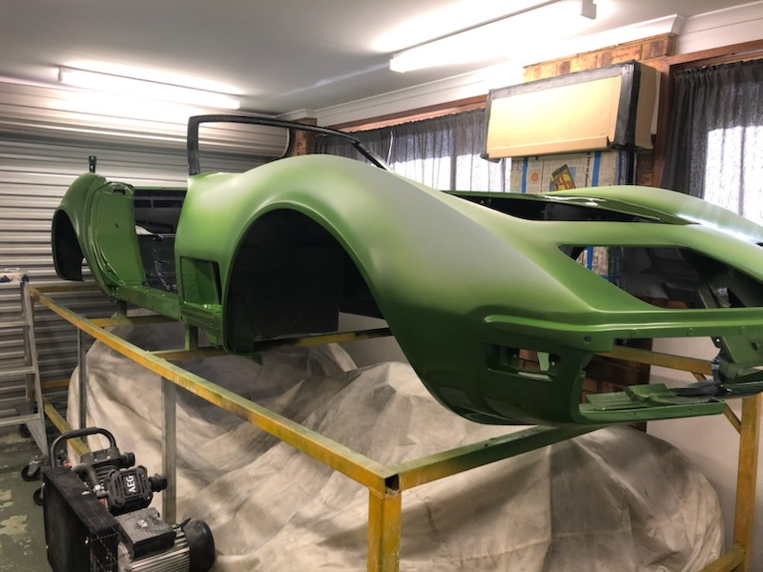
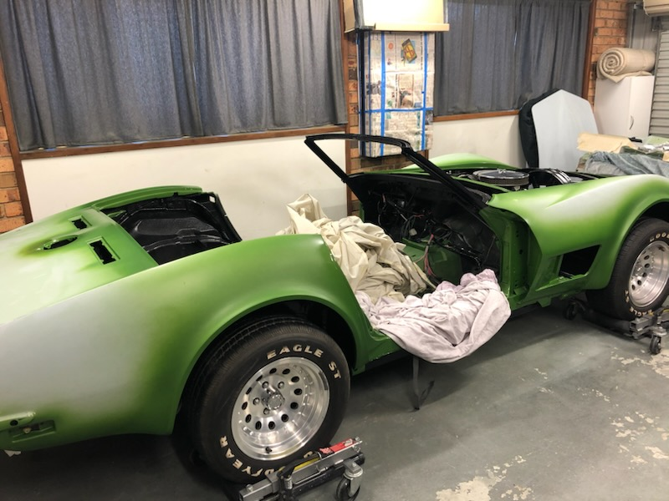
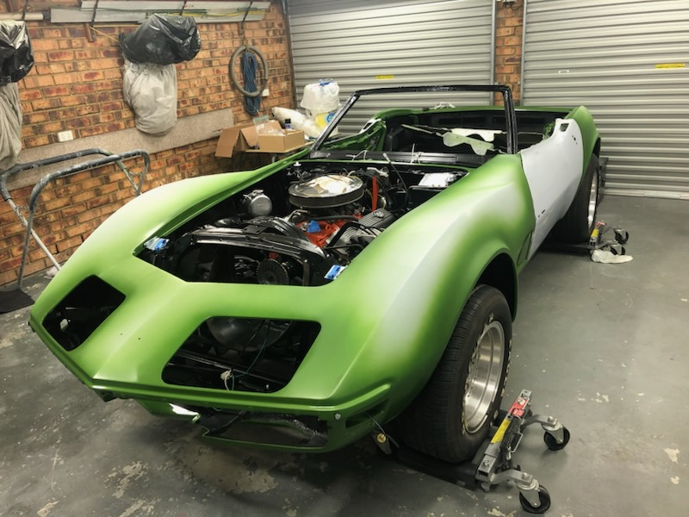
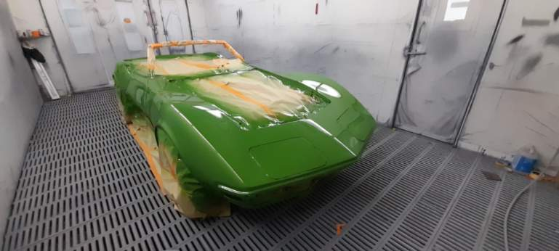
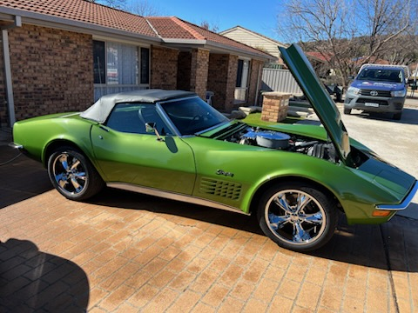
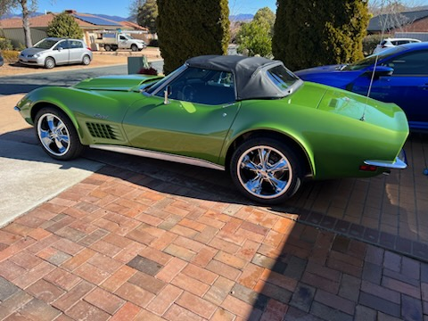
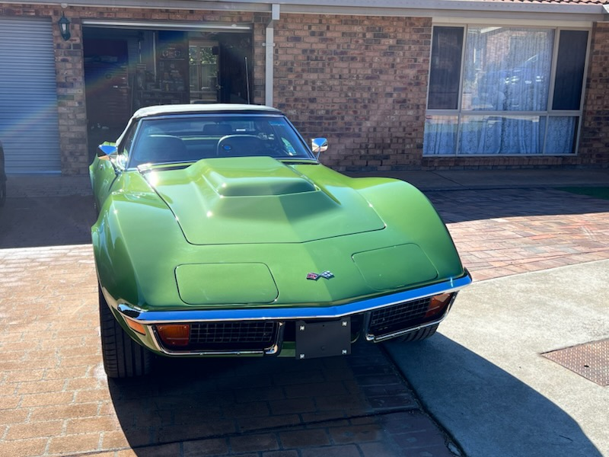

Corvette parts for sale by Peter Steve

Box 1

84 - 91 ashtray - $15.00 used
84 - 96 console cup holder - $10.00 used
84 - 89 LH door small defog vent genuine GM #14071839 - $10.00 new
84 - 89 horn button emblem - $50.00 used
84 - 90 rear and front black badges 1 pair - $30.00 used
84 - 89 rear lettering black with red surround - $20.00 used
85 - 90 air dam/front spoiler LH and RH pair - $100.00 new
85 - 90 air dam/front spoiler LH and RH pair - $100.00 new (yes, 2 sets)
90 - 93 convertible deck lid outer plastic black trim RH genuine GM #10103850 - $40.00 new
90 - 93 convertible deck lid outer plastic black trim LH genuine GM #10103851 - $40.00 new
93 – 96 nose emblem special edition chrome ring genuine GM #10198699 - $50.00 new

Box 2

53 - 55 bumper - front vertical front - $150.00 used
53 - 55 bumper - front vertical front - 1 pair - $300.00 used
53 - 60 powerglide safety switch bracket hose - $30.00 new
53 - 57 licence bumper/bumperette front U bracket - 1 pair - $50.00 new
56 - 62 neutral safety switch shield bracket - $10.00 new
84 - 90 rear letter emblem $25.00 used
84 - 88 5.7L bottom radiator hose gates #21728 - $10.00 new
86 - 91 AC Delco spark plug wire set/5.7L – 12073939/1917226/618W FREE used
97 - 04 front brake duct grille/screen – stainless steel Z06 style - $25.00 pair
97- 04 side cove grille/screen – stainless steel Z06 style - $30.00 pair
97 - 99 wheel centre caps chrome/carbon fibre centres – set of 4 - $80.00 new
97 - 99 wheel centre caps – set of 4 original - $40.00 used
2001 Z06 under hood display insert – black with Z06 - $40.00
06-07 6L engine oil filter – AC Deco PF59, 25014748 - $10.00 new
Narva ultra blue parking lights 12V – 5W T-10MM 17190BL2 - $5.00
(Do not know what they fit)

Box 3

68 - 82 T-top latch bolt with rubber tip – one only $5
68 – 91 AC Delco oil filter #PF1218 #25160561 $5
71 – 81 PCV valve cover grommet steel $5
84 AC Delco air breather element #FB-93 #25042206 $50
84 – 89 horn button emblem used $20
84 – 90 gas tank emblem used $10
84 – 90 hood emblem used X 2 - $5ea
84 – 93 lumbar support seat switch bezel $10
91 – 96 gas tank emblem used $10
2000 Genuine service manuals x 3 NEW $400

Peter can be contacted at corvetteguru@hotmail.com or on 0408 297 178

